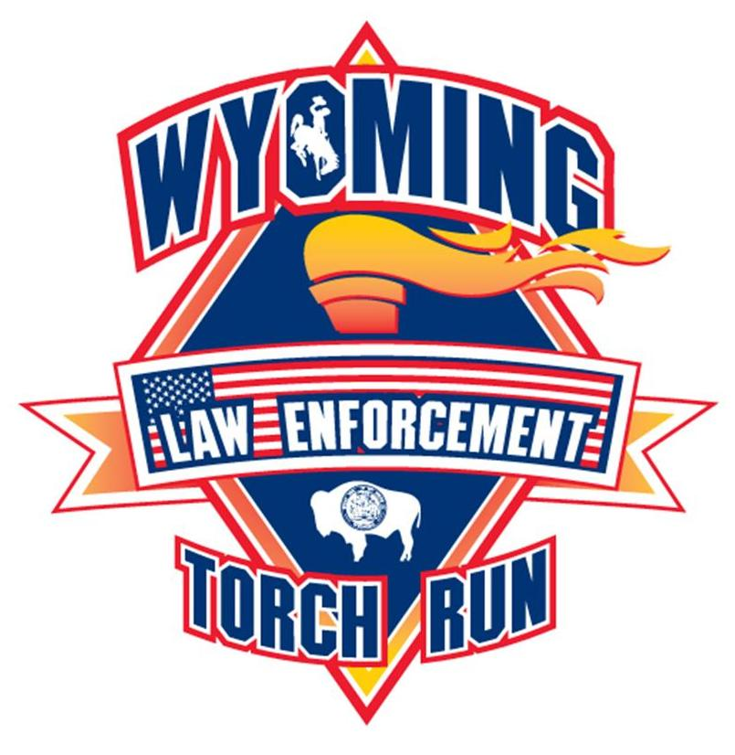





**Development & Fundraising**

**A. Frequently Asked Questions**

C:\Documents and Settings\pdowse\Local Settings\Temporary Internet Files\Content.IE5\2MKMSGI8\MCj01953100000[1].wmf

1. How Do Area and Local Programs Raise Funds?

Area and Local programs are encouraged to develop fundraising events to support their programs. Special Olympics Wyoming guidelines and policies should be reviewed to insure the success of the event. Looking for ideas, contact Regan Diller at [specialevents@specialolymipcswy.org](mailto:specialevents@specialolymipcswy.org).

2. What Happens to the Money Raised?

As Area or Local programs raise money all funds are deposited into an authorized Special Olympics Wyoming account. In each account, a record of funds is kept to track to each Area or Local program. This accounting is shared on a quarterly basis.

3. How do I start an Area or local fundraising event?

**1st:** Before you begin a fundraising event read over polices and guidelines for Area or local fundraising.

**2nd:** Fill out the Fundraising Notification Form (available in this Coordinators Manual or from the Field Services Coordinator) and send it to the Field Services Coordinator at Special Olympics Wyoming. Special Olympics Wyoming should be notified at least 60 days before any fundraising event takes place involving Special Olympics. The Coordinator in consultation with Special Olympics Wyoming Fundraising staff will review the information and notify you when the project is approved or declined.

**3rd:** Keep detailed records of the fundraising event including dated receipts and bills.

**4th**: After the event, complete the Post Event Report (located on page 93 of this manual). All monies received must be submitted to an authorized account to be credited to the Area or local account. No funds are to be retained by the Area or Local program.

**5th:** If you would like Special Olympics Wyoming to send a thank you letter to participating donors or supporters of your event please attach the list with the Post Event Report.

**B. Policies and Guidelines**

* State, Area or Local program fundraising projects or events may not have any direct affiliation with tobacco or alcohol products. The no tobacco or alcohol policy is a rule of Special Olympics, Inc. and is adhered to by Special Olympics programs nationally.
* Local programs may not conduct their own raffles. This policy is to insure the integrity of the entire organization.
* Area and Local programs may not enter into verbal or written agreements with any fundraising company or individual. Only the CEO/President of Special Olympics Wyoming, with the approval of the Board of Directors, may enter into any contractual fundraising agreement involving any level of Special Olympics in Wyoming.
* A Local program may not have its own bank account.
* All funds raised by or donated to an Area or Local program must be sent to an authorized Special Olympics Wyoming account in a timely manner. Do not hold cash or checks donated to Special Olympics for more than 30 days.
* Funds should be sent by check or money order. Cash may be delivered to the office. Do not mail cash. A receipt will be issued. Always request a receipt for cash.

Why? As an organization we can collect best practices and be able to share them with other local programs.

* An Area or Local program may conduct fundraising activities on its own. If that activity will handle $250 or more, a Fundraising Event Notification Form must be submitted to Special Olympics Wyoming 60 days prior to the event. A Post Event Form must also be submitted following the event.
* Area and Local Programs are encouraged to solicit local companies for corporate donations. Before soliciting, submit a copy of the solicitation letter and a list of companies you plan to approach. Special Olympics Wyoming will review the list in a timely manner and inform programs of the companies that have already given to Special Olympics Wyoming at any level for that given year.

**C. Finer Points of Fundraising**

# NOTES TO REMEMBER!

1. Any fundraising project conducted in the name of Special Olympics must have a project notification form submitted and approved before the project begins.
2. Be certain your budget is in good working order so that you can justify where the money is going. Don’t be offended when specific questions come up; you must believe that your expenditures and income is justified.
3. Don’t be afraid to ask! Potential donors do not give until someone asks them. Avoid taking “no” as an answer – persistence pays off.
4. Know your potential donor and the reason why and when they want to give:

* Is it someone’s relative?
* Are they looking for positive affiliation?
* Are they doing it to make themselves feel better?
* Is this part of an advertising budget?
* Is this part of a donation/community support budget?
* When do they do their budgeting?
* Is there a foundation associated with the individual or company?
* Is there an interest in Estate Planning?

The more you can target your prospects, the better your chances of getting the response you want.

1. Don’t be afraid to have more than one activity going on. The more the general public hears about Special Olympics – the easier it is to approach. Remember, fundraising is an excellent public education tool.
2. Don’t criticize other promotions (non-profits other than Special Olympics) and be supportive of promotions benefiting other levels of Special Olympics. **A donation on any level benefits everyone**!
3. Asking for money/support is giving people an opportunity to participate in a cause they care about.
4. More heads are better than one. Utilize a committee! Do not think it is easier to do it alone! Taking an athlete and two people to make ’the ask’ is a compliment to the potential donor.
5. Thank you letters, certificates or plaques are a must to all who help in projects. Make lists of volunteers and donors to keep in files. Keep a record of costs for future use.

*The best fundraisers truly believe they are doing people a favor by asking them for a contribution – enjoy the ASKING!*

**D. Local Fundraising ideas**

Fundraising within Wyoming conducted by the North America office or other agencies include:

* Direct Mail Program – up to six times per year
* Dial America – Magazine Sales and 7.5% of every magazine sale returns to Wyoming
* Heritage Medallion – telephone solicitations and donations

Here are ideas based on time commitments, volunteer recruitment, investment returns and target audience. In choosing which fundraising opportunity is best for your local program you can be creative while achieving your revenue goals and don’t forget to factor in FUN!

**1-3 People**

* *Letter writing* to individuals and organizations requesting donations requires minimal effort and can net returns of $25-$500 with only the expense of postage and letterhead. All contact lists should be vetted through the State office. Follow-up phone calls are recommended.
* *Grant writing* takes more of a time investment but can net a higher financial gain, anywhere from $250 to $2,500. Check with Priscilla Dowse, CEO and President, to check on availability of grants in your community.
* *Civic organizations* welcome volunteers to come and speak on behalf of the organization. Special Olympics is a Global emphasis with the Knights of Columbus and the American Legion. Other civic organizations including, but not limited to, Kiwanis, Optimists, VFW, Eagles, Moose and the Elks have proven to be supportive financially as well as major volunteer contributors. Win Win!
* *Employee match programs* are also a great source of volunteer hours and financial contributions combined. Reaching out to the local manufacturing, mining, corporate businesses to inquire if they have matching opportunities for donations or volunteer time.

**6-10 People**

* *Garage/Bake/Cookbook sales* are one of the best ways to raise awareness and funds in your neighborhood. Gather your friends and gather your stuff, whether it be baked goods, garage treasures, used books or recipes and create your sale! Invite students, teachers, churches and other local organizations to include all ages in the fun!
* *Roll/walk/skate/swim/dance a-thons* brings in dollars through registration fees and by sponsoring a mile, an hour or a lap.
* *Guests serving guests* generates dollars by offering your services in a local restaurant bussing tables, hosting or waiting tables. There are many variations on this event, for example, the volunteer staff donates all tips to the organization or a certain percentage of the sales is donated.
* *Concession proceeds* have been successful in different areas of the state for various events like rodeos, mountain man rendezvous and sporting events. Contacting the concessionaire and requesting that a certain percentage of the proceeds will benefit your local program, or if you volunteer to park cars, a certain percentage of that fee would go to the local program.

**15-20 People**

* *Auctions/Gala Events/Casino Nights and Benefit dinners* by far are the largest fundraising opportunities outside of State events, but, are also the most time consuming and generate the highest expenses as well.

**Law Enforcement Torch Run -** Law Enforcement agencies collect pledges, run the torch, sell t-shirts and facilitate additional fundraisers (i.e. walks, dinners, motorcycle rides…) for Special Olympics.

**Jackalope Jump -** Participants collect pledges to take a cold water plunge.

***ALL MONEY RAISED IN WYOMING STAYS IN WYOMING***

While there is an assessment fee to be an accredited program within Special Olympics Inc., the return of thousands of dollars in materials, training and program information exceeds what we make as a payment to the founding organization.

**E. Funding Request Letter Sample**

January 1, 2010

Have the correct name and title:

Mr. John Smith, President

Acme Co.

Sunny Lane

Jelm, WY 80000

Dear Mr. Smith,

*Explain who you are and your specific request for writing, example:* I am the head coach of the Pineboro Tigers and I am writing to ask for your support. The Tigers are the Special Olympics team that represents our town. Special Olympics provides sports training and athletic competition for children and adults with intellectual disabilities. There are 16 athletes on the Tigers and six volunteer coaches.

*Explain why you need support, example:* We need your help to raise part of the housing and meal costs for our team to attend the 2010 Summer Special Olympics Games at the University of Wyoming in Laramie.

Explain your reason, for example: All of our athletes are training to compete in Basketball and track and field events. The Games are May 20-22, 2010. We need to raise only $$$$ per athlete. That cost includes transportation, two nights lodging, seven meals.

*What have you done to support the project?* The Tigers have been practicing dry land skills since DATE and we plan to get out on the snow each week between now and the Winter Games. Our volunteer coaches have spent an average of 10 hours with each athlete in training.

*What are the benefits?* The Games are a great experience for our athletes. The sports venues are beautiful and the opportunity to spend time away from home in a big lodge with friends and teammates is really fun.

*Make a specific request .*Would you please sponsor one or more of our athletes to attend the 2011 Special Olympics Summer Games? I will call you early next week to discuss the possibilities of this proposal and provide any additional information you may need.

The state office of Special Olympics Wyoming has authorized us to conduct this fund raising effort. If you have any questions about our local organization you can call *Staff Liaisons name* at (307) 235-3062.

Thank you for your consideration.

Sincerely,

John Goodcoach

Phone Number



AREA/LOCAL FUNDRAISING

**EVENT NOTIFICATION FORM**

All Area/local programs planning a fundraising event projected to handle over $250 must fill out this form and submit it to the Director of Field Services at Special Olympics Wyoming 60 days before the event. Special Olympics Wyoming will review the application and return it to the Area/local program with 15 days. The Area Coordinator will also receive a copy of all applications for events in their region.

Date of Request: ______________________ (Must be 60 days before the event)

Area/Local Program: ________________ Contact Person: __________________

Home Phone: _________________________ Work Phone: _____________________

Fax: ________________________________ Email: __________________________

Address: _________________________ City: _____________________ Zip:___________

Name of Fundraising Event: ___________________________________________________

Date of Event:_________________________ Location of Event: ________________

Briefly describe the event:

The amount you expect to raise before expenses (Income): $ ___________________

Anticipated expenses of entire event: $ ___________________

Net return expected (Income less Expenses): $ ___________________

**Return Form To:**

Special Olympics Wyoming

232 E. 2nd St., Suite 201

Casper, WY 82601

Fax: 307-235-3063



**AREA/LOCAL FUNDRAISING**

POST EVENT REPORT

Area/Local Program: ________________ Contact Person: __________________

Home Phone: _________________________ Work Phone: _____________________

Fax: ________________________________ Email: __________________________

Address: _________________________ City: _____________________ Zip:___________

Name of Fundraising Event: ___________________________________________________

Date of Event:_________________________ Location of Event: ________________

**Income: $ ___________________**

*Must be submitted for deposit in your Special Olympics Wyoming account.

**Expenses: $ ___________________**

*Submit all bills for payment to the Special Olympics Wyoming Office Manager.

*Expenses will be deducted from you Special Olympics Wyoming account.

**Net: (Income less Expense)** $ ___________________

**In-Kind/Donated Services and Products:**

(Please list item and value. Additional items may be listed on the back of this report.)

Item: _____________________________________ $ ____________________

Item: _____________________________________ $ ____________________

**Thank you:** Our Area/local program would like a thank you sent to:

Name/Company Address City State Zip

__________________________________________________________________________________

__________________________________________________________________________________

**Follow-up Notes:** *Comments on how the event went, what you would keep the same, what would you change.*

**Return Form to:**

Special Olympics Wyoming

232 E. 2nd St., Suite 201

Casper, WY 82601

Fax: (307) 235-3063