Online Application Instructions & Questions: 2019-2020 Cycle
We are pleased to announce that the application period for the Special Olympics Unified Champion Schools National School Recognition Program is now open for the 2019-2020 school year cycle. The application cycle closes on June 1, 2020. This document is designed to help you successfully complete and submit your application.

application instructions:
Phase 1: Drafting Your Responses

Prior to starting the online application, it is recommended to first create a draft of your responses (see application questions within this document for each grade level category). This will allow you to collect all necessary information and save a copy for your records. Once the responses are ready, they can be easily copied and pasted into the online application.

Phase 2: Completing the Online Application

Step 1 of 3: Create Application Account
- Visit our UCS National School Recognition Program landing page at https://specialolympics.submittable.com/ to access the applications for all three grade levels.
- All applicants are asked to create an account so that they have the ability to go back into the system to access saved application drafts.

On the landing page, click the “apply” button for the grade level application that you will be filling out.
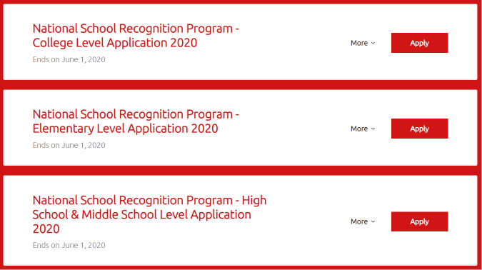

Scroll to the bottom of the page and click “create your account.”
Fill in your contact information.

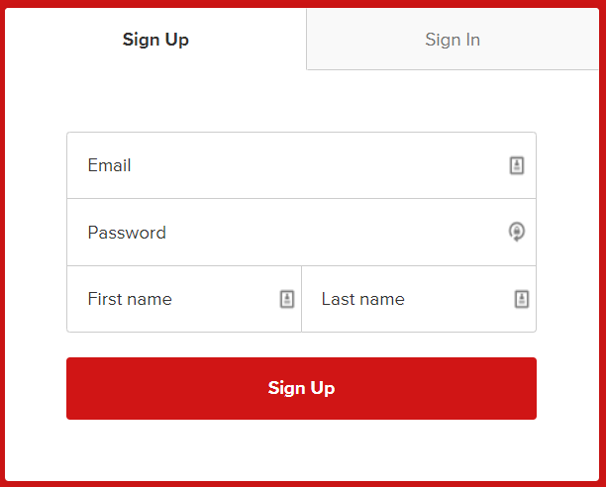

Click “continue”

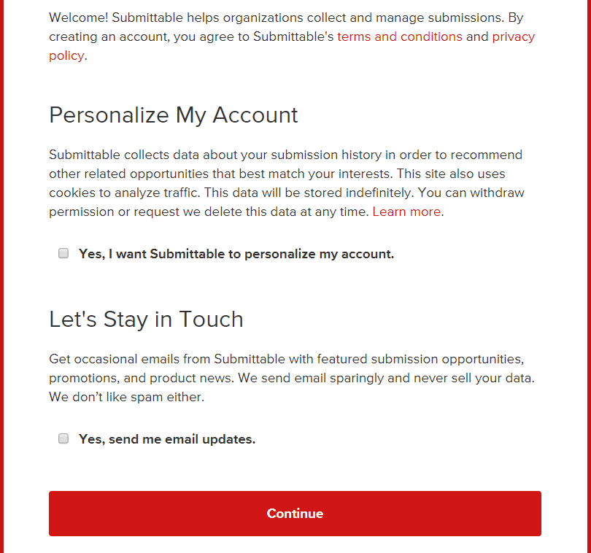

You will then be re-directed back to the application page where you can either begin answering the questions or save your draft.

Step 2 of 3: School Application
- Complete all application questions.
- You can save a draft of your responses to the application questions at any time before the submission deadline of June 1st by scrolling to the bottom of the application and clicking “save draft.”
- You will need to log back into your account in order to re-access your saved draft.

Step 3 of 3: Submit Application
- Once you have completed your responses to all of the questions and are ready to submit, click “apply.”

Confirmation

- After clicking “apply,” you should see this page confirming that the application has been submitted. You should also receive a confirmation email shortly after submitting.

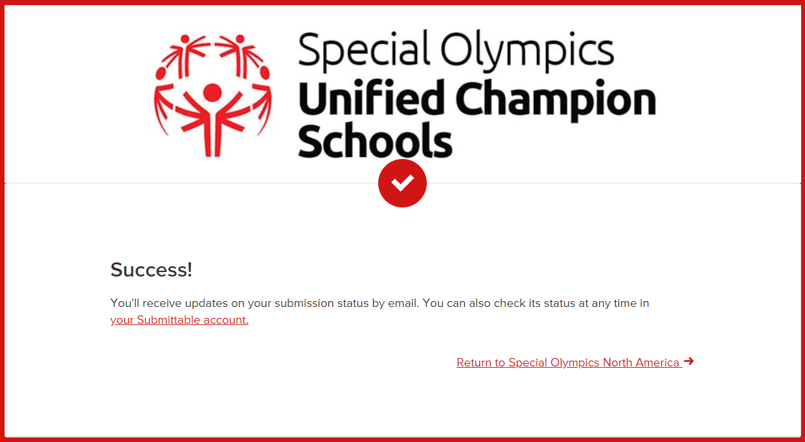

application Questions:
NOTE: Each grade-level category has its own set of unique standards and questions. Below are the application questions for elementary, middle & high school (same), and college.
As mentioned above, it is recommended to first create a draft of your responses prior to submitting the online application. This will allow you to collect all necessary information and save a copy for your records. Once the responses are ready, they can be easily copied and pasted into the online application.

RENEWAL STATUS:
This year, the National Recognition Program application will include a question on recertification. In order to give schools the opportunity for continued recognition, as well as ensure quality programming, there will be a four-year renewal process for all national banner schools. Schools will submit their applications in the same platform, Submittable, as first time schools.
*All banner schools from the 2016 cycle are now eligible to renew their banner status this 2020 cycle!
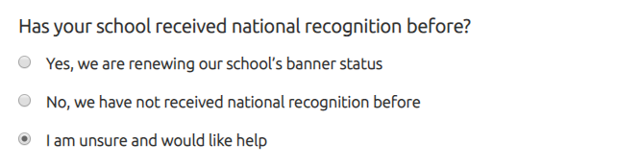
If you are unsure, the last option (above) will clarify:
NOTE
The Special Olympics Unified Champion Schools® National Recognition Program first started in 2016. Each school year since, schools have been able to apply for “banner status.”
If your school filled out an application for the National Recognition Program in 2016, and was approved and received national recognition:
This means you are renewing your banner status and should go back to the last question and click on “Yes, we are renewing our school’s banner status.”
If your school filled out an application for the National Recognition Program in 2016-2019, and was not approved and did not received national recognition:
This means you are eligible to apply for banner status and should go back to the last question and click on “No, we have not received national recognition before.”
If your school filled out an application for the National Recognition Program in 2017-2019, and was approved and received national recognition:
This means your school currently has banner status and is not eligible for renewal at this time.
If your school has never filled out an application for the National Recognition Program:
You should go back to the last question and click on “No, we have not received national recognition before.”
If you have any questions regarding your status, please email usschools@specialolympics.org.
When you have completed this question, you will be prompted to begin filling out the Standards-related questions:

Elementary school level:

SPECIAL OLYMPICS UNIFIED SPORTS and Young Athletes:
A fully-inclusive sport/activity program that combines students with and without intellectual disabilities. Examples include such things as school-based Unified Sports teams, Unified PE, developmental sports activities or Young Athletes. Standards 1-4 relate to the Unified Sports component:
STANDARD #1 - "Unified Sports and/or Young Athletes are available for students across multiple grade levels of the school." Please describe how participation in Unified Sports/Young Athletes is available for multiple grade levels:
STANDARD #2 - "Unified Sports and/or Young Athletes occur regularly over the course of the school year and includes a culminating event or competition (i.e.; continuous weekly training in lead-up to an event).” Please list the approximate number of weeks of Unified Sports/Young Athletes participation, a description of the culminating event/competition, and the date of the culminating event/competition:
STANDARD #3 - "Each sport/activity has an adult coach who has received training on Unified Sports or Young Athletes.” Please list the name(s) of coaches who have been trained:
STANDARD #4 - "Special Olympics programming is officially recognized by the school in a similar style as other sports/activities." Please describe how Special Olympics programming is recognized by the school:

INCLUSIVE YOUTH LEADERSHIP:
Students with and without intellectual disabilities work to lead advocacy, awareness, inclusion and other Special Olympics activities throughout the school year. Examples include such things as a Unified Club, inclusive leadership training for students, “Get Into It” lessons, students helping to lead school inclusion projects or students from higher grades coaching those in lower grades. Standards 5-7 relate to the Inclusive Youth Leadership component:
STANDARD #5 - "A Unified Club or inclusive student group which meets regularly throughout the school year for social and/or leadership activities (can be classroom-based, during the school day, or extra-curricular).” Please provide the name of the club (if applicable) along with a description of the activities that take place within this club/group:
STANDARD #6 - "Students of all abilities are given opportunities to take leadership roles during sports/activity training sessions." Please describe the types of leadership roles given to students with and without disabilities during Unified Sports/Young Athletes activities:
STANDARD #7 - "The inclusive club/group has an adult liaison and is officially recognized by the school in a similar style as other clubs/activities.” Please provide the name of the adult liaison and a description of how the club/group is recognized by the school:

WHOLE-SCHOOL ENGAGEMENT
Awareness and education activities that promote inclusion and reach the majority of the school population. Examples include such things as “Fans in the Stands” or cheer teams for culminating events, poster contests, essay contests, Respect Campaigns, “Get Into It” lessons, school assembly with an inclusion theme, bus “send-offs” for Unified Sports teams, or student fundraising. Standards 8-9 relate to the Whole-School Engagement component:
STANDARD #8 - "At least two whole-school engagement activities are implemented per school year." Please provide a description for each whole-school engagement activity that took place:
STANDARD #9 - "The Unified Club or inclusive student group works alongside school staff to lead the awareness activities.” Please describe how students with and without disabilities were involved in planning/leading the whole-school engagement activities:

SUSTAINABILITY
Strategies and plans which help ensure the three Unified Champion School components will continue into the future and truly become part of the school culture. Examples include such things as student fundraising, Unified Sports/Club expenses included in school budgets or a designated school staff liaison for Special Olympics activities. Standard 10 relates to Sustainability of the components:
STANDARD #10 - "The school is currently self-sustainable or has a plan in place to sustain the three components into the future." Please describe how the school will sustain the 3 components into the future:

Additional Information (Optional)
You may use this optional space to share any additional details about how your school has created a climate of inclusion (i.e.; other activities, videos, articles, stories).

ADMINISTRATOR SIGN-OFF
As a school administrator, I approve all information in this application and hereby nominate our campus to be considered for the honor of receiving national banner recognition (please type name of administrator as a digital signature).

middle & high school level:

SPECIAL OLYMPICS UNIFIED SPORTS:
A fully-inclusive sports or fitness program that combines an approximately equal number of students with and without intellectual disabilities. Examples include such things as: Interscholastic Unified Sports, Unified PE or Unified Intramurals. Standards 1-4 relate to the Unified Sports component:
STANDARD #1 - "The school offers Unified Sports in at least 2 seasons throughout the school year." Please list which sports/seasons your program participates in and the number of students who participate for each sport (this also includes Unified Fitness):
STANDARD #2 - "Unified Sports participation occurs regularly over the course of each sport season or school term and includes competition." Please list the approximate number of weeks of Unified Sports participation and number of total competitions (can include multi-team tournaments and head-to-head games):
STANDARD #3 - "An adult coach for each sport who has received training on Special Olympics Unified Sports." Please list the name(s) of coaches who have been trained:
STANDARD #4 - "Unified Sports is officially recognized by the school in a similar style as other athletics/activities." Please describe how Unified Sports teams are recognized by the school (i.e.: included in lists of clubs/sports, stipend for coaches, included in school-wide recognition, scheduling, transportation, etc.)
INCLUSIVE YOUTH LEADERSHIP:
Students with and without intellectual disabilities working to lead advocacy, awareness, inclusion and other Special Olympics activities throughout the school year. Examples include such things as: Unified Clubs, inclusive student councils or similar types of inclusive student groups. Standards 5-7 relate to the Inclusive Youth Leadership component:
STANDARD #5 - "A Unified Club or student group that offers leadership opportunities/training for students with and without intellectual disabilities." Please provide the name of the club (if applicable) along with a description of the activities that take place within this club/group:
STANDARD #6 - "The inclusive club/group meets at least once per month throughout the school year." Please list the approximate date of the first meeting, how often the club/group meets and the approximate number of meetings held during the school year:
STANDARD #7 - "The inclusive club/group has an adult liaison and is officially recognized by the school in a similar style as other clubs/activities." Please provide the name of the adult liaison and a description of how the club/group is recognized by the school:

WHOLE-SCHOOL ENGAGEMENT
Awareness and education activities that promote inclusion and reach the majority of the school population. Examples include such things as the Spread the Word >> Inclusion Campaign, Pep Rallies or “Fans in the Stands” for Unified Sports teams, Respect Campaigns or student fundraising. Standards 8-9 relate to the Whole-School Engagement component.
STANDARD #8 - "At least two whole-school engagement activities per school year." Please provide a description for each whole-school engagement activity that took place:
STANDARD #9 - "Students with and without disabilities are involved with planning and leading the awareness activities." Please describe how students with and without disabilities were involved in planning/leading the whole-school engagement activities:

SUSTAINABILITY
Strategies and plans which help ensure the three Unified Champion School components will continue into the future and truly become part of the school culture. Examples include such things as: student fundraising, Unified Booster Clubs or Unified Sports/Club expenses included in school budgets. Standard 10 relates to Sustainability of the components:
STANDARD #10 - "Is currently self-sustainable or has a plan in place to sustain the 3 components into the future." Please describe how the school will sustain the 3 components into the future, including sources of funding:

Additional Information (Optional)
You may use this optional space to share any additional details about how your school has created a climate of inclusion (i.e.; other activities, videos, articles, stories).

ADMINISTRATOR SIGN-OFF
As a school administrator, I approve all information in this application and hereby nominate our campus to be considered for the honor of receiving national banner recognition (please type name of administrator as a digital signature).

college level:

SPECIAL OLYMPICS UNIFIED SPORTS:
A fully-inclusive sports or fitness program that combines an approximately equal number of students with and without intellectual disabilities. Examples include such things as Intercollegiate Unified Sports, Unified Sports Clubs or Unified Sports Intramurals. Standards 1-4 relate to the Unified Sports component:
STANDARD #1 - "Unified Sports is offered in at least 2 seasons throughout the school year." Please list which sports/seasons your program participates in and the number of students who participate for each sport.
STANDARD #2 - "Unified Sports participation occurs regularly over the course of each sport season or school term and includes competition." Please list the approximate number of weeks of Unified Sports participation, including practices, and number of total competitions/games (can include multi-team tournaments and head-to-head games).
STANDARD #3 - “Participating students and coaches (if applicable) have received training on Special Olympics Unified Sports." Please list the name(s) of students and/or coaches who have been trained.
STANDARD #4 - "Unified Sports is officially recognized by the school in a similar style as other campus intramural or club sports." Please describe how Unified Sports teams are recognized by the school.

INCLUSIVE YOUTH LEADERSHIP:
Students and local Special Olympics athletes work to lead advocacy, awareness, inclusion and other Special Olympics activities throughout the school year. For example, an official Special Olympics College Club. Standards 5-7 relate to the Inclusive Youth Leadership component:
STANDARD #5 - "A Special Olympics College Club which is led by students and engages Special Olympics athletes." Please provide the name of the student-led club along with a description of the activities that take place within the club, and how it includes Special Olympics athletes beyond sports.
STANDARD #6 - "The Special Olympics College Club meets at least once per month throughout the school year.” Please list the approximate date of the first meeting, how often the club meets and the approximate number of meetings held during the school year.
STANDARD #7 - "The Special Olympics College Club has a faculty advisor and is officially recognized by the school in a similar style as other registered student organizations.” Please provide the name of the advisor and a description of how the club is recognized by the school.

WHOLE-SCHOOL ENGAGEMENT
Awareness and education activities that promote inclusion among the broader school population. Examples include such things as Spread the Word to End >> Inclusion Campaign, Pep Rallies or “Fans in the Stands” for Unified Sports teams, Respect Campaigns or student fundraising. Standards 8-9 relate to the Whole-School Engagement component.
STANDARD #8 - "At least two whole-school engagement activities are implemented per school year.” Please provide a description for each whole-school engagement activity that took place.
STANDARD #9 - "Students and local Special Olympics athletes are involved with planning and leading the awareness activities.” Please describe how students and Special Olympics athletes were involved in planning/leading the whole-school engagement activities.

SUSTAINABILITY
Strategies and plans which help ensure the three Unified Champion School components will continue into the future and truly become part of the school culture. Examples include such things as student fundraising, Unified Sports expenses included in school budgets, or yearly funding received for being a registered student organization. Standard 10 relates to Sustainability of the components:
STANDARD #10 - "The school is currently self-sustainable or has a plan in place to sustain the three components into the future and has on-going communication with the local or state Special Olympics Program." Please describe how the school will sustain the 3 components into the future, including funding, and how the school communicates with local/state Special Olympics personnel.

Additional Information (Optional)
You may use this optional space to share any additional details about how your school has created a climate of inclusion (i.e.; other activities, videos, articles, stories).

ADMINISTRATOR SIGN-OFF
As a campus recreation professional or club advisor, I approve all information in this application and hereby nominate our campus to be considered for the honor of receiving national banner recognition (please type name of campus recreation professional or club advisor as a digital signature).

